**Machine Learning**

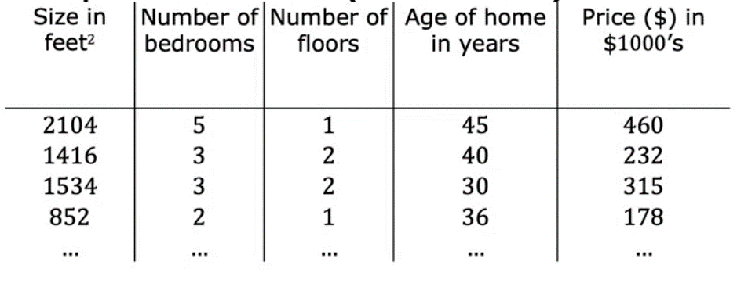Multiple Features Linear regression

Here we have multiple inputs (features) and of course a single output (target)

The pros of multiple features will make the model stronger because it will specify each output more from others.



j = order of feature or column

n = No. of columns

i = order of row or sample

x (i, j) = row, column m = No. of rows or samples

For this example, let’s have some intuition about numbers:

For the first factor (Size of house) if has a small effect on the final price of it.

Second factor (no of bedrooms) it increases the price by 4000 usd.

Third factor (no of floors) it increases price by 10k usd.

Fourth factor (the age of the house) it has a negative effect on price so it lowers the price by 2k usd.

Fifth factor (base price) it raises all houses’ prices by 80k usd.

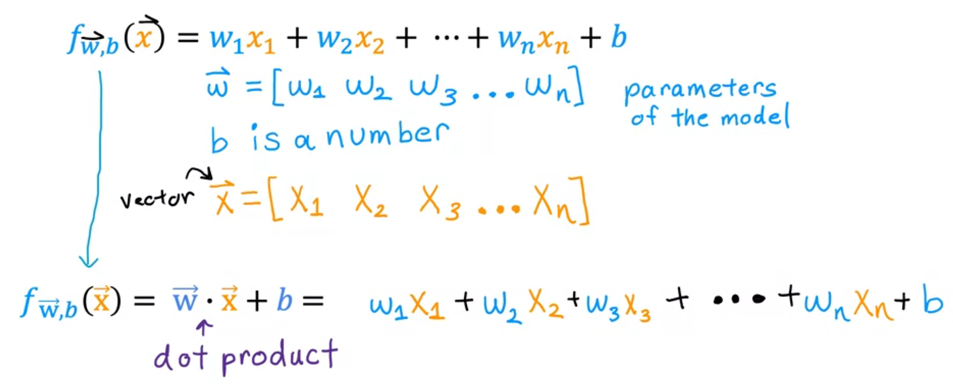

Gradient Descent for Multiple Linear regression

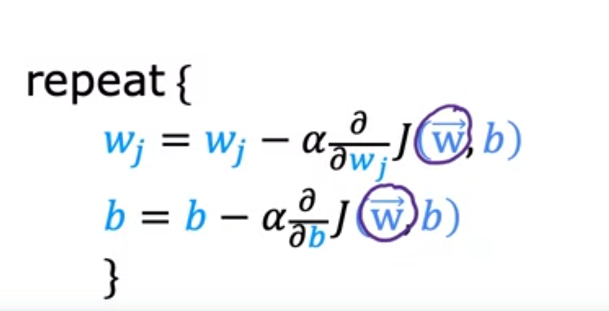

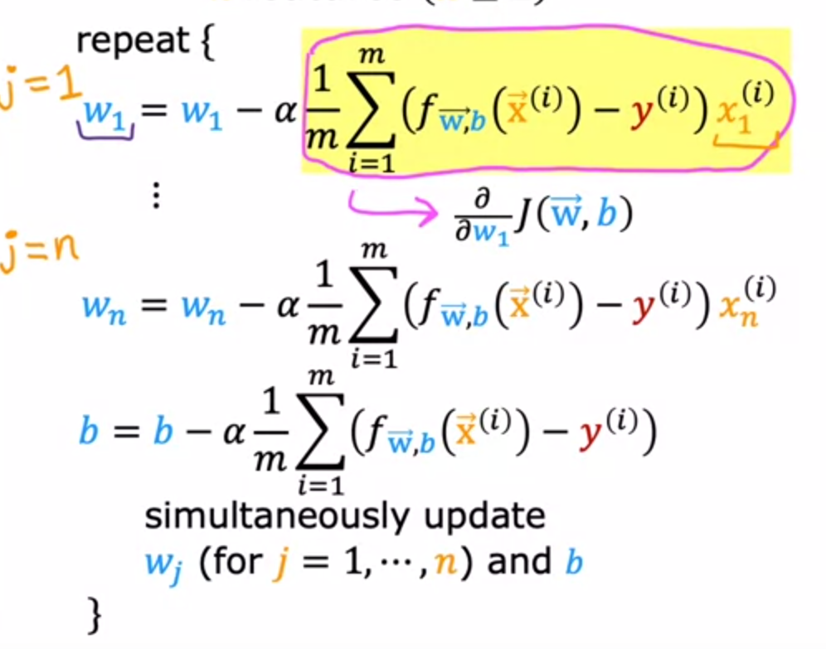

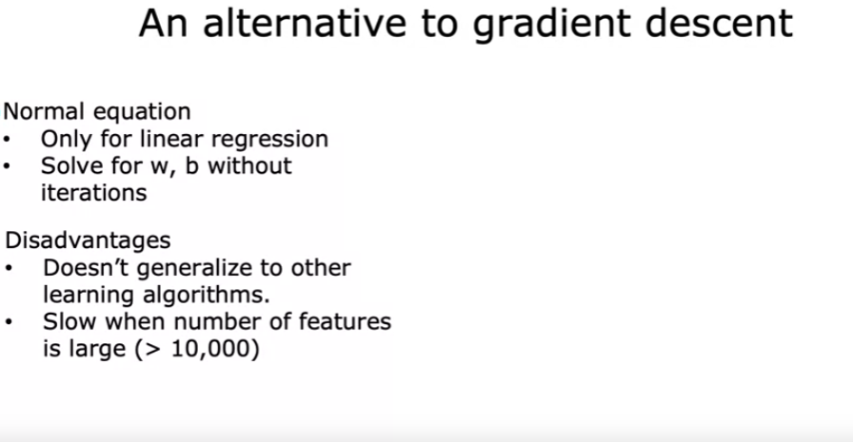

___

To make the model faster we need to make our features scaled between 0 and 1 or -1 and 1

If the ranges are very far from others

There are many methods of feature scaling

First Method Second Method Third Method

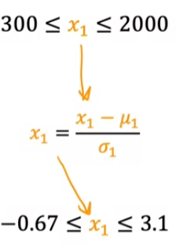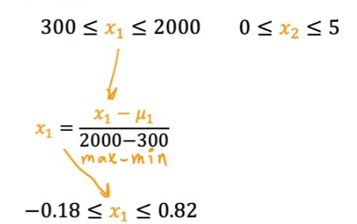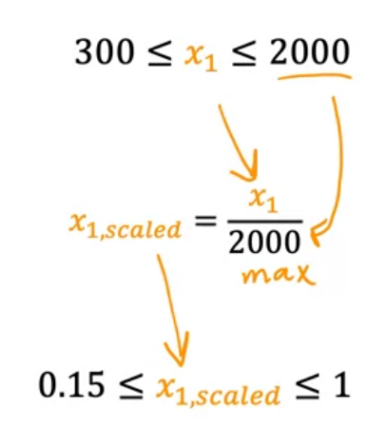

Meu is the mean Sigma is the standard deviation